KAKA CHICK TRANSMITTER TRIP
2 January 2019

Friends of Rotoiti members Wayne Sowman and Peter Hale accompanied Jen Waite and Corey Mosen (DOC) and Ron Moorhouse (Wildlife Restoration Manager Project Janszoon) on a trip to attach radio transmitters to kaka chicks. This is part of ongoing kaka research at Nelson Lakes to investigate chick survival and dispersal patterns as well as to locate active and new nesting sites. It is intended to fit all trees with active nest sites with aluminium bands above and below the entrance hole to protect the chicks as well as the all-important nesting females.

Transport to the cellphone towers at the back of the Borlase farm saved a fair amount of climbing and was followed by a 45 minute bush- bash up the St Arnaud range to the historic nest site in a large red beech tree.

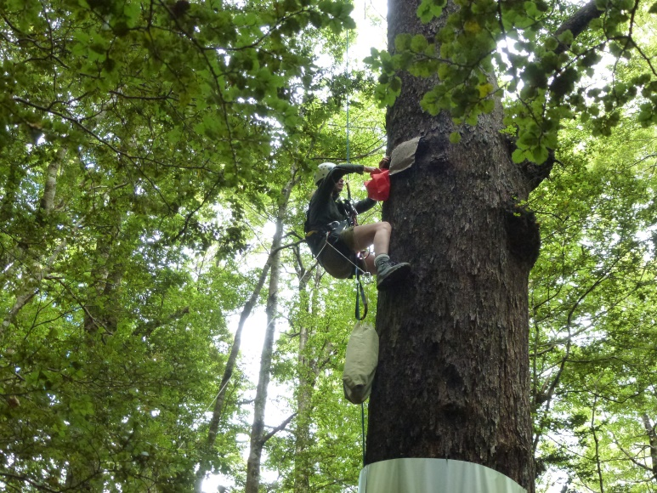
Jen climbed to the “back door” of the nest cavity but found the hole too tight to get her arm in so Corey managed to widen the entrance using a multitool. The four chicks were still beyond reach so a catch-bag on the end of a meter long wire handle was utilized and the chicks removed one at a time, always leaving one to reduce the stress on a returning parent.
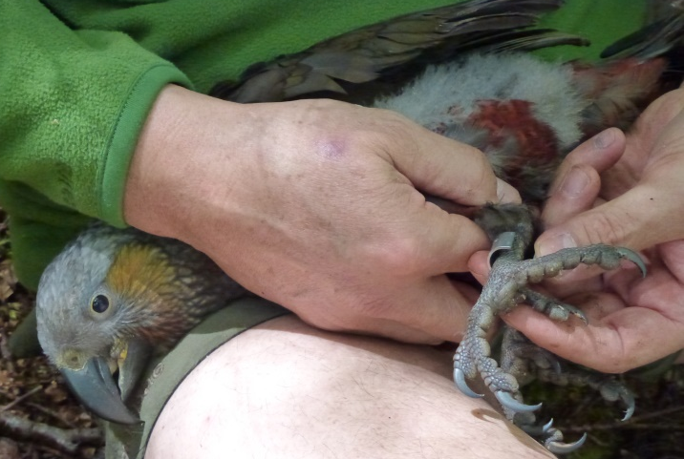

Each chick was banded, weighed and had the beak-length measured indicating two males and two females.

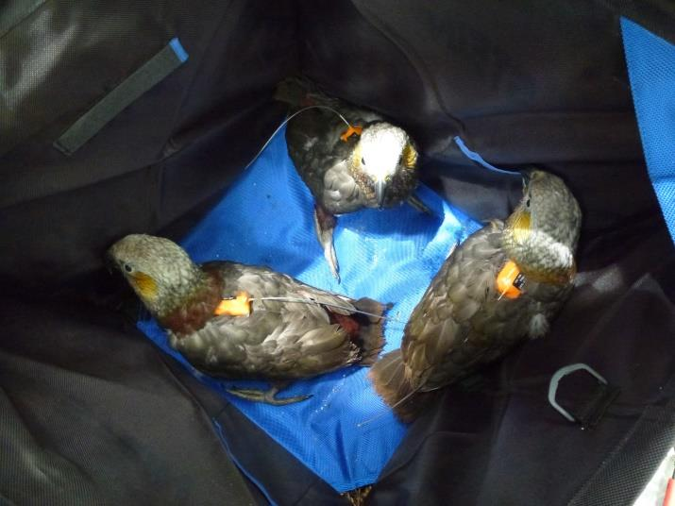
A Sirtrack backpack transmitter was then fitted to each. This transmitter weighs 19g with a 2-year battery life and is attached to the bird via a harness made of 3mm braided nylon cord. Corey fitted the first to demonstrate the technique then Jen fitted the remaining three. The procedure is quite intricate and Jen was understandably nervous however she proved up to the task under the experienced eye of Corey. The procedure required two assistants to hold the bird.

The chicks were returned to their home, the back door closed and the climbing rope removed.

While retrieving the chicks Jen found an old transmitter lying in the bottom of the nest cavity. Ron and Les Moran’s records showed this was from a bird that was radio-tagged in April 2000. The bird was monitored in the 1998–1999 season so had been caught earlier and the condition of the harness indicated she had been killed on the nest sometime after 2000–2002.

Wayne and I thoroughly enjoyed the experience and it highlighted the difficulty of “hands on management” of kaka.

